Bahria University,

Karachi Campus



LAB EXPERIMENT NO.

_______7_______

LIST OF TASKS

|  |  |
| --- | --- |
| TASK NO | OBJECTIVE |
| 1 | **Write a python program to implement the support vector machine on the built-in dataset from sklearn.datasets library (e.g. load_iris() ). Implement the following different kernels of SVM and compare the accuracy score.**   1. **Linear** 2. **Polynomial** 3. **Gaussian** |
| 2 | **Design a workflow with the help of Knime to implement the Support vector machine algorithm on any classification dataset.** |

Submitted On:

___________

(Date: 16/5/23)

**LAB # 07**

**Task # 1: Write a python program to implement the support vector machine on the built-in dataset from sklearn.datasets library (e.g. load_iris() ). Implement the following different kernels of SVM and compare the accuracy score.**

1. **Linear**
2. **Polynomial**
3. **Gaussian**

**Solution:**

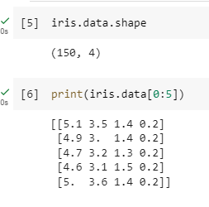

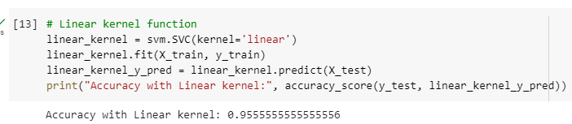

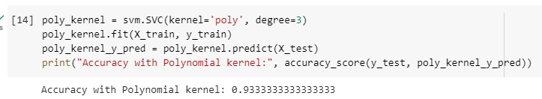

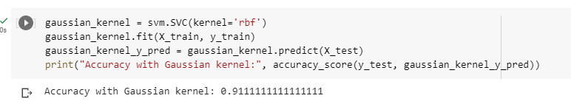

**Task # 2: Design a workflow with the help of Knime to implement the Support vector machine algorithm on any classification dataset.**

**Solution:**

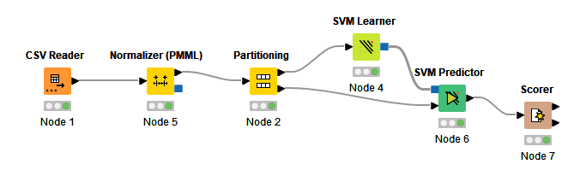

**Output:**

